Qualys

VMDR Threat Feed

* View, query, and

Prioritization Reports

The VMDR Prioritization Report identifies and remediates the vulnerabilities that pose a risk to an organization. VMDR comes with two options that help in prioritization based on your need. You can prioritize using either the options **Threat Intelligence** or **TruRisk Mode**.

The VMDR Prioritization Report helps you prioritize and patch vulnerabilities using multiple factors, including Asset Context, Vulnerability Age, Threat Intelligence, and Attack Surface dynamics. You can also prioritize using the Qualys TruRisk Mode, which uses Asset Risk Score – a combination of Asset criticality and Qualys Detection Score or QDS.

Threat Detection and Prioritization

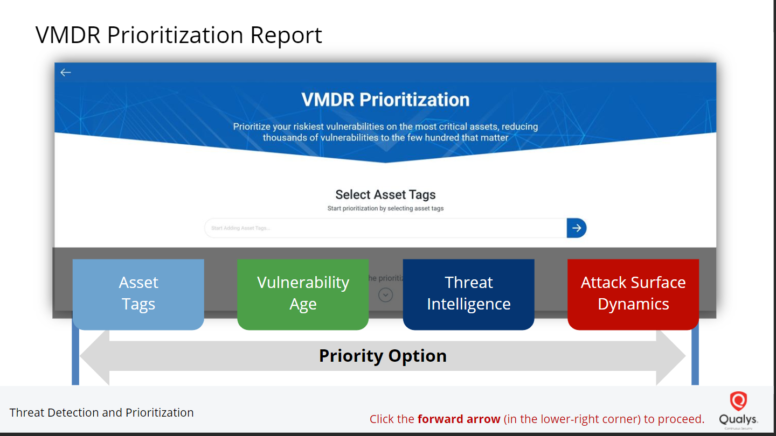

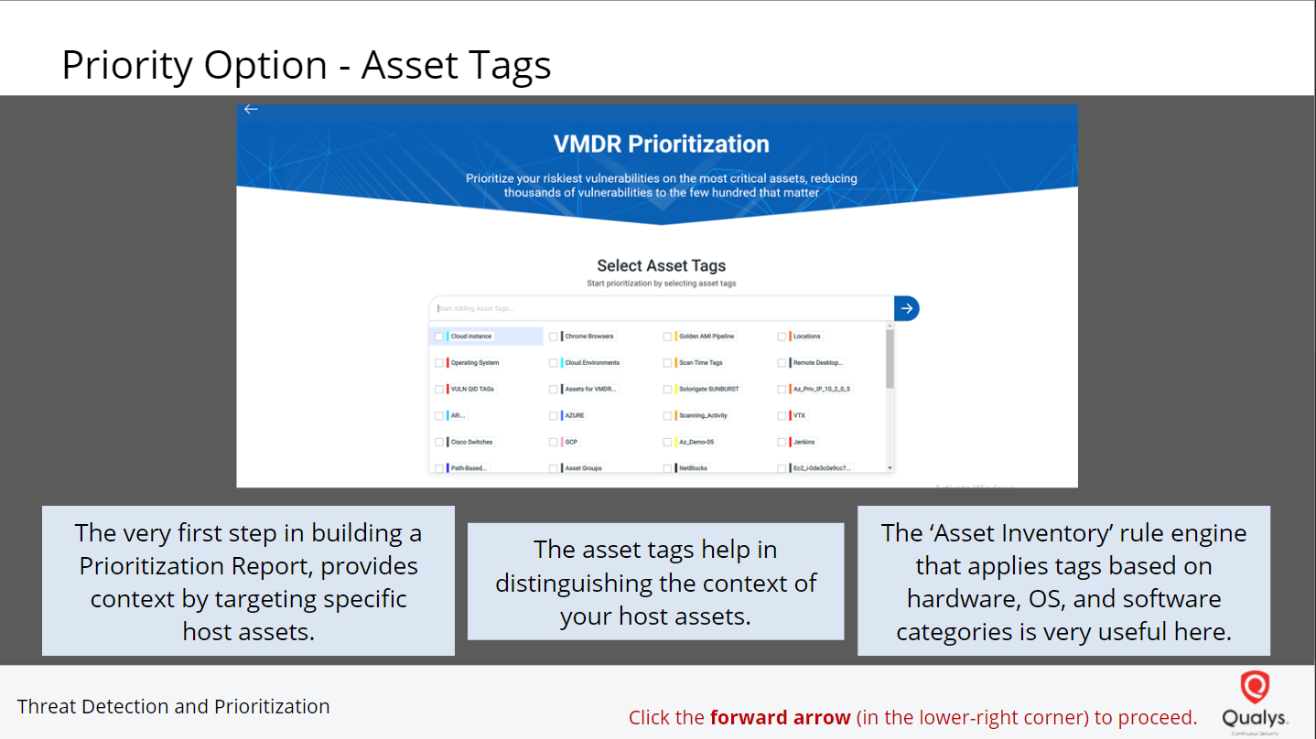

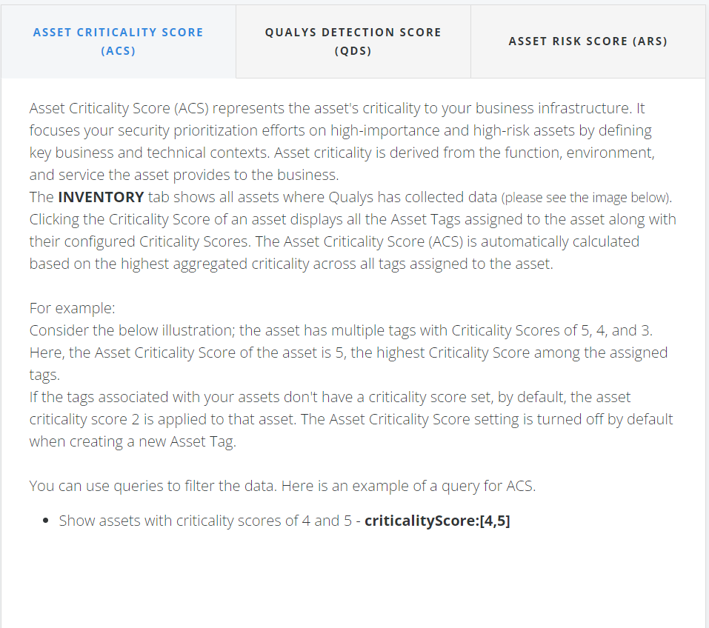

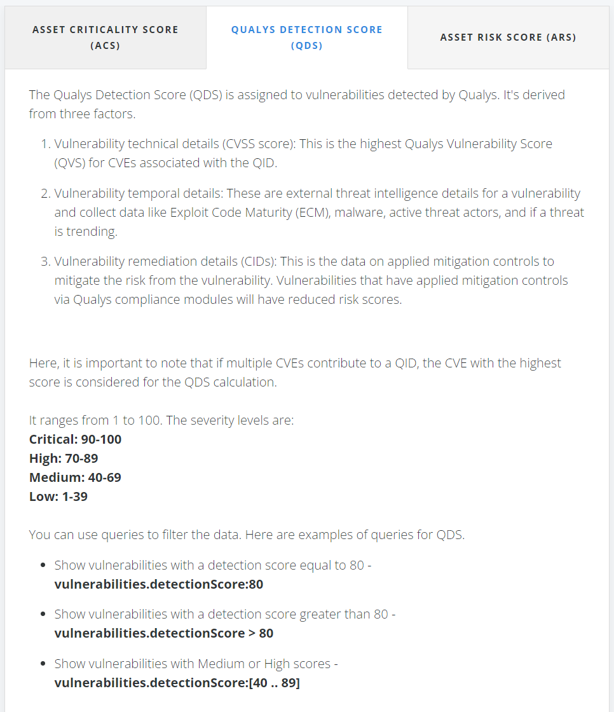

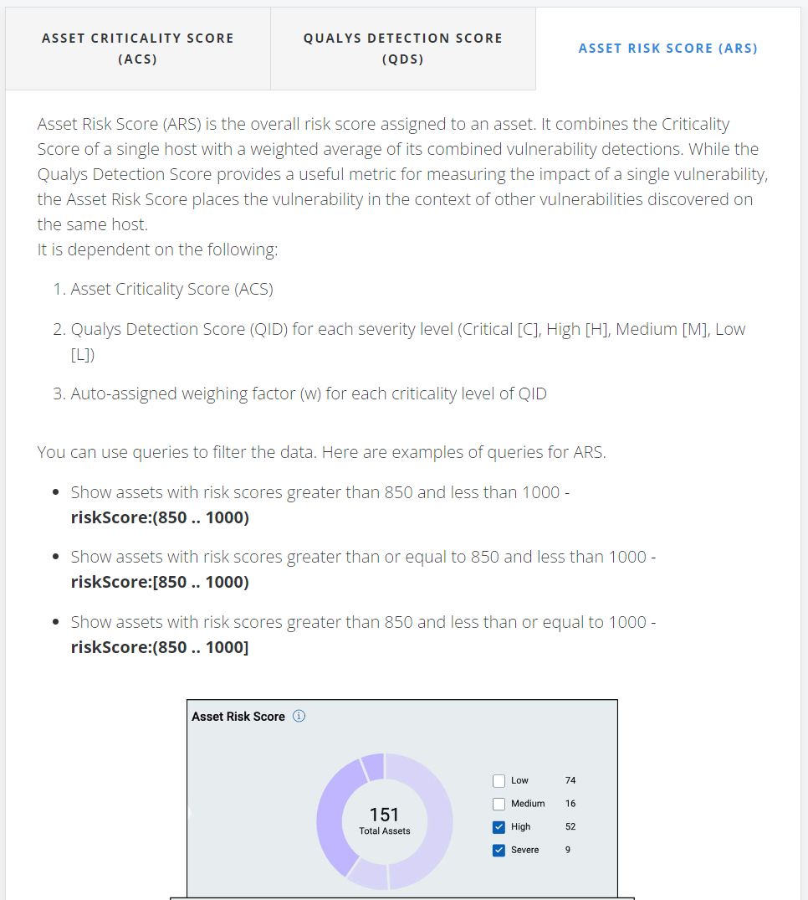

**Calculating Asset Risk Score**

As mentioned earlier, the Asset Risk Score is calculated based on different parameters. The following formula is used to calculate the ARS:

**ARS = ACS * {wc(Avg(QDSc)) + wh(Avg(QDSh)) + wm(Avg(QDSm)) + wl(Avg(QDSl))}**

In the above formula:  
-  **ACS** - Asset Criticality Score  
-  **w**- weighing factor for each severity level of QIDs [critical(c), high(h), medium(m), low(l)]  
-  **Avg(QDS)** - Average of Qualys risk score for each severity level of QIDs on that asset

The weights assigned to QDS based on their range is:

* Critical (90-100) – weights = 1.0
* High (70-89) – weights = 0.7
* Medium (40-69) – weights = 0.4
* Low (1-39) – weights = 0.25

You can click any ARS value to understand how it is calculated.

